“Go back to when you were 13 years old. What would you tell 13-year-old you about social media that you know now?”
I asked ChatGPT to summarize the responses
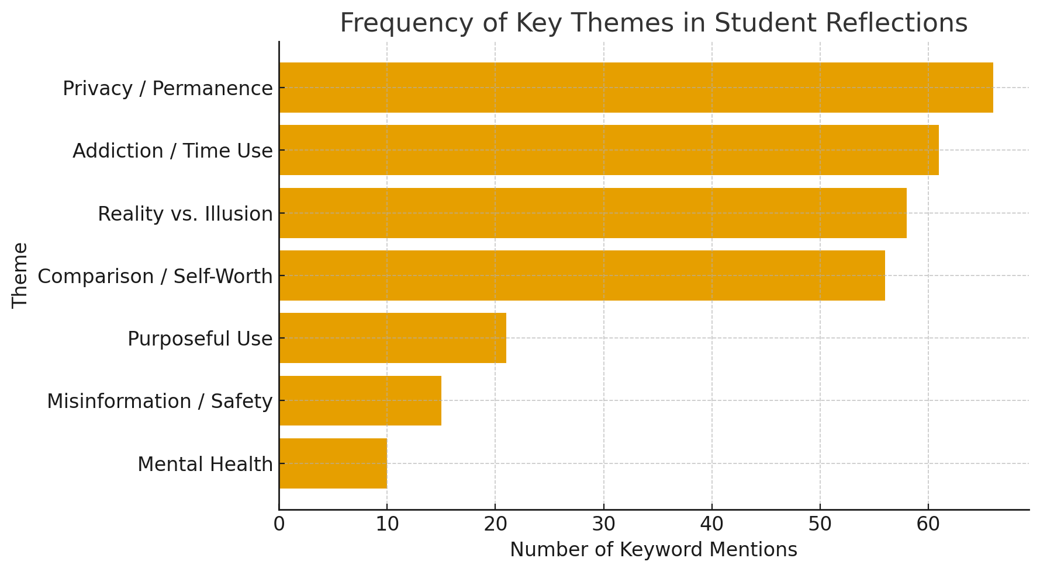

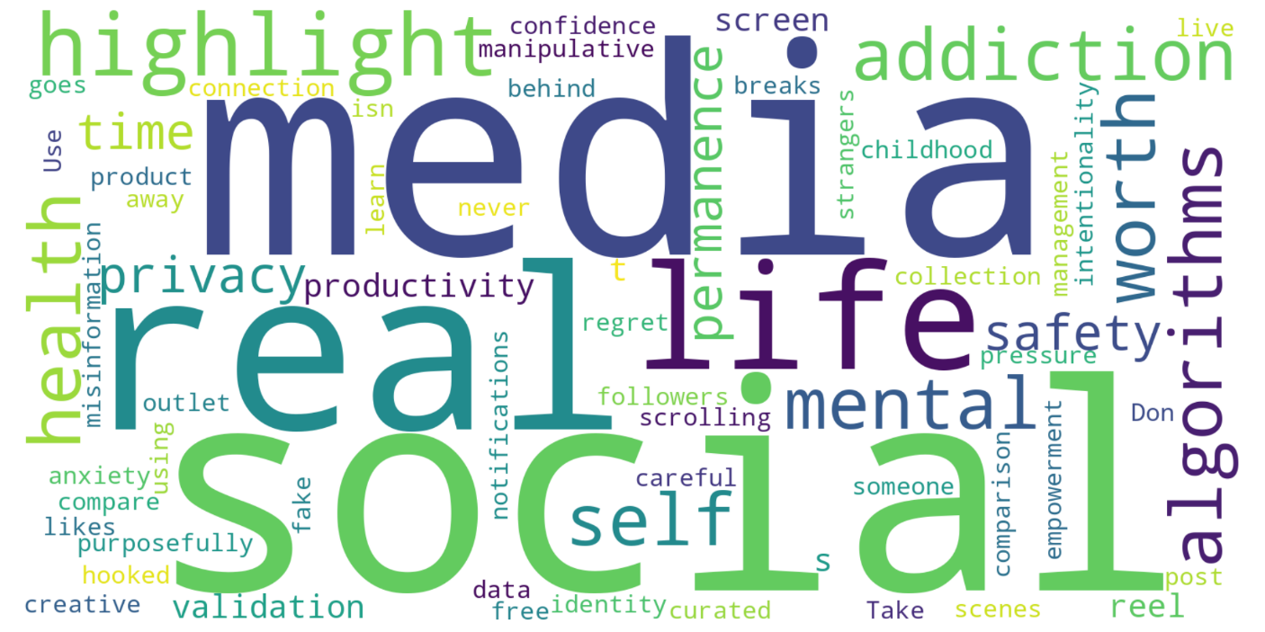
Core Themes
1. Reality vs. Illusion
- Nearly every student mentioned that social media does not reflect real life.
- They would tell their younger selves that people only post highlight reels, not the full picture, and that comparing themselves to others online is unhealthy and unfair.
- Several used words like “fake,” “curated,” and “manipulative” to describe social media content.
2. Addiction and Algorithms
- Many students now understand that social media is engineered for addiction.
- They cited algorithms, notifications, and endless scroll design as deliberate tactics to hold users’ attention and collect data.
- Several mentioned feeling “hooked” or “mindlessly scrolling,” and a few said they have tried deleting apps like TikTok or setting time limits.
3. Mental Health and Self-Worth
- A strong theme was mental health awareness, especially the damage done by constant comparison and the pursuit of likes or followers.
- Students said social media made them feel inadequate, anxious, or less confident.
- They now realize that likes and followers don’t define their value.
4. Privacy, Permanence, and Safety
- Many warned their younger selves to be careful what they post and who they interact with.
- Advice included: “Don’t talk to strangers,” “Once it’s online, it’s forever,” and “Keep accounts private.”
- Several referenced data collection and surveillance, noting that free apps make users the “product.”
5. Time Management and Productivity
- Students regretted the time wasted scrolling and said they’d rather focus on real experiences, friendships, or self-improvement.
- Some emphasized that time online is time lost: “There’s literally no point in spending hours chasing likes.”
6. Use Social Media Purposefully
- A few recognized that social media can have value—for learning, connecting, or career opportunities—if used mindfully.
- One student said they now use it only for networking; another said it can be a creative outlet if approached critically.

💬 Representative Advice to 13-Year-Old Selves
- “Don’t compare your behind-the-scenes to someone else’s highlight reel.”
- “If it’s free, you are the product.”
- “Be careful what you post—it never goes away.”
- “Take breaks and live more off-screen.”
- “Use it to learn, not for validation.”
- “Social media isn’t real life.”

🔍 Minor but Notable Perspectives
- A few students said they don’t regret waiting to join social media, appreciating the “real childhood” they had.
- One or two said social media could be a tool for building a following or income, suggesting a more entrepreneurial view.
- A handful mentioned cybersecurity or misinformation, warning against believing everything seen online.

🧩 Overall Sentiment
The class’s reflections overwhelmingly convey a sense of regret and wisdom—that while social media once seemed exciting, it has proven manipulative, addictive, and mentally draining. Yet, students also demonstrate nuanced understanding: they see potential for learning and connection, provided it’s used with intentionality, moderation, and awareness.

Responses from students, these were copied directly from the assignment and were not changed.
- I’d tell little me to set a time limit on social media apps or not download them. I
also wasn’t allowed to have social media or a phone until I had a driver’s license.

- Feeds are highlight reels—don’t compare.
• Turn off most notifications.
• Keep the phone out of the bedroom.
• Follow accounts that teach; unfollow ones that drain.
• Don’t post angry; wait, reread, then decide.

- I would tell my 13-year-old self not to be so gullible and that not everything you see online is
true or real. I would try to explain to myself that on social media, you are only seeing what
people want you to see and that it is not an accurate representation of their life or who they are.
I would also tell myself to stop comparing myself to other people.

- If I could talk to my 13-year-old self, I’d tell them to be careful about how much time they spend
on social media and not to take everything they see so seriously. A lot of what people post isn’t
real life; it’s just the best parts they want others to see. I’d remind myself not to compare my life
to someone else’s highlight reel and to focus more on real moments instead of likes or
followers. I’d also tell myself to think before posting anything, because once something’s online,
it’s basically there forever. Most of all, I’d say to use social media for fun and connection, not to
look for validation.

- I would tell my self to be very careful with how they approach social media. Yes it can be good
and fun to see what your friends are up to or share what you are doing. However, nothing truly
gets deleted from the internet once it has been posted.

- I would tell my 13-year-old self to not believe everything that you see online. People only
post the good stuff about their lives, so it is easy to feel like you are behind or aren’t
good enough. Don’t care about the number of likes, don’t overshare online, and don’t let
it mess with your confidence.

- would tell myself to take opinions with a grain of salt before deciding on your own
stance. I would say that there are people online that just hate for the sake of it. I would also say
that creative outlet and knowledge online.

- This is something that we actually agree on. I’ve always had very little interest in social
media because I thought it would be bad for me. I only have Instagram, and I only go on it once
every couple of years to check on the videos one of my friends sends me. I lost it for a couple
years even. So, I guess I could go to 13-year-old me to tell me that I was right. Maybe, it’s going
to get worse? Now there are people abusing their children, going to extremes and harming
themselves, and harassing people in public for views.

- I would say that you shouldn’t be pressured by what you see and know others are doing on
social media and just be your own person.

- As someone who wasn’t allowed to have social media or even a phone for a long time, it would
mostly just be a warning for what’s to come. I appreciate being able to say I had a childhood
where I didn’t spend all my time inside looking at what other people were doing because it gives
me a sense of reality that I can see will not exist for many people in the future. I would tell 13-
year-old me to stay off social media as long as you can and to focus on what’s happening in the
real world. I would tell myself that overall, it’s a toxic environment that was not designed to help
me out in any way and much like everything free in this world, I would be losing something.

- I would tell 13-year-old me to stop blindly clicking “Allow Cookies.” I had no idea until the first
assignment in this class that you can actually still view a website if you click “No Cookies.” I’d
also tell myself not to download Instagram, Snapchat, or TikTok. I’d explain that the algorithms
watch everything you click, like, and scroll past and then show you more of the same stuff to get
you addicted. Even things like “tagged photo” notifications are designed to get you to click and
keep scrolling. The apps are not random. They are built to grab your attention and collect data
about you, and get you to spend hours upon hours on them, they don’t care about you’re
wellbeing they care about the money they can make of of you.
I feel like if I knew this at 13, I would honestly not have downloaded these apps but now it’s just
so hard to step away. Recently I was able to delete TikTok, but now I just do the same thing on
Instagram, mindlessly scrolling through reels. I wish I could get myself off social media entirely.
Every time I try, I end up going back, and I realize now how much they shape the way I think about myself and compare myself to others. I’m working towards a goal of getting completely off
but I just can’t seem to rip that band aid completely off yet.

- I would tell a 13-year-old not to believe everything they see online. Before you spread
information, make sure it is accurate. This would be helpful for 13-year-olds as a lot of
information is spread online that isn’t truly correct and accurate, fact checking information is
very important especially in todays media

- I would tell myself that I am the product, and that if something is free then you are for
sale. I would tell her that social media was trying to take her attention away from things
that matter, to just a waste of time. I would also tell her that it is designed to keep her on
there as long as possible, it’s fake as all-get-out, and that it is going to influence what
she thinks, feels, and does, and that she should be independent and making all those
decisions by herself

- I would tell my 13 year old self not to realize many posts online are rigged to have engagement
and are dishonest. I would try to have myself realize that many things on the internet are not
what they seem, meaning that there are different intentions behind what people are posting. I
would say to post less and think before sharing anything. I would tell myself to not compare my
life to what I see on social media. It is also important to keep my account private and only talk to
people I know. Social media can be fun but it should not control how you feel about yourself.

- If I could talk to my 13-year-old self about social media, I’d tell myself that not everything I see
online is real. I’d remind myself that people usually post their best or top moments, not their
struggles, so comparing myself to others is unfair and unhealthy. I’d also explain that social
media companies are built to keep me hooked by showing me content that triggers emotions
like excitement or jealousy or gives me a dopamine rush. I’d encourage myself to use it
mindfully, to connect with friends and learn new things, but not to measure my worth by likes or
followers. Most importantly, I’d say to take breaks, spend time offline, and never forget that real
relationships happen face-to-face, not through a screen.

- That pretty much everything posted online has an ulterior motive therefore, to realise
why people are posting what they are posting. In addition, I would tell myself how fake
and dangerous social media can be with collecting data and knowing everything about
you.

- I would tell my 13-year-old self to not talk to strangers on the internet. It seems like an obvious
warning, but children, my past self included, are too trusting

- I would tell my 13-year-old self to be very careful about social media. Social media isn’t
a reflection of real life, people are showing off the best parts of theirs behind a screen. I
would tell myself to live in the moment and take breaks from social media.

- I would tell 13-year-old me that everything I put on social media exists forever and will
never be able to be deleted permanently. I would also tell myself that it can be addictive
and once you are on social media it’s hard to feel like you can delete it. Everything is
designed to get you to engage and what you see on social media is put there with
intention for you to see. I would make it clear that the platforms are glorified. No one’s
worth is determined by what people comment on a post or how many likes you get and
that you don’t have to participate in social media just because most children your age are.

- I would tell my 13-year-old self that social media is rigged to make me addicted to
scrolling and wanting to be on social media to not “miss out” on stuff. It’s programmed
to make me so obsessed that I'm glued to my phone. It would create new insecurities
about myself and my body when I didn’t even see it as an issue, until I saw people who
had similar features get made fun of on social media.

- When looking back to when I was 13, I would tell myself to post things that bring me joy,
and not to compare myself to the idealistic women i’m staring at on my screen. SO much of
social media fosters negative thoughts and negatives connotations that finds and brings out all
of your insecurities. I would tell myself that so many have the same thoughts I do, and to do
what I can to make me feel empowered online.

- I would tell myself at 13 that social media is not real life. Most people post their positives, though if they
compare their own lives to others'; it could leave a teenage developing a poor self-image. Additionally, I
would caution my own self that anything posted, or shared, does not go away. It’s always out there. Also
be careful with time. While social media can be entertaining, it takes time away from what others are
doing without compensation of that time. Or just take time - social media can leave a person feeling
insecure or confused about themselves and/or their friends.

- The main advice I would direct towards my younger self would be that no matter what,
what you are seeing is most likely fake. The photos people post are a snapshot of the
good parts of life, not the bad parts. I would also explain the importance of remembering
that everything you put online is online forever. Technology is not going away, and social
media is only getting bigger and bigger. Anything you put out there is out there for the
entire world to witness.

- I would tell my 13-year-old self that social media is a big waste of time and that the majority of the things
that I look at, or watch are not real life. I think that when I was younger, I used to spend a lot of time on
social media, wasting time, trying to get myself more followers or likes. As I’ve gotten older, I’ve
realized that the time I spend scrolling can be used so much more productively doing something else to
better myself. There is literally no point in spending my time looking at other people’s content or their
lives, or chasing likes. Likes and followers don’t mean anything. Having 10 real friends is a lot more
important than 100 followers. I would tell myself to spend my time making more real friends and less
time trying to get followers online. I also used to compare myself to things that I saw on social media. As
I’ve gotten older, I have realized that so much of it is fake and that it’s important to put things into
perspective; people only put out what they want people to see. Nobody is as perfect as they seem online.
They all go through life the same way that I do.

- I would say “I know it feels exciting to be connected to everyone all the time but be
careful. Social media isn’t just fun and games. It’s designed to keep you scrolling, often at the
cost of your focus, sleep, and self-esteem. Don’t measure your worth by likes or followers.
Remember, people only show the best parts of their lives online and comparing yourself to that
can make you feel less than you really are. Be kind, think before you post, and protect your
privacy. Not everyone online has good intentions, and once something’s out there, it’s hard to
take back. Use social media to learn, connect, and express yourself, but don’t let it define you.
You’re so much more than your profile.”

- I would probably tell her to delete social media until she is a bit older, and if she odes
keep social media I would tell her that she does not have to post everything all the time.
She probably would not listen to me.:/

- I would tell 13 year old me not to care about how I look or what I post because the only
thing that should matter is that I like what I post and not to care what other people think.

- I would tell her to never compare herself to the girls she sees on social media. I would tell her to
strictly use it as a tool for information and not something to be viewed when you are bored. I
would tell her to never download TikTok because of how addictive it’s algorithm is. I would say
that you can have platforms like Instagram to stay up to date with family and friends and sports
but only view them on your laptop instead of your phone. Having it readily available to view at
any instant is the real problem. I would also tell her to educate herself on businesses taking
data, social media business models, and the goal of these platforms.

- I would tell myself that there are better uses of your time. It is
something that you are are free to experience but it is all about
your relationship with it.
I would also probably tell myself the quote from the movie that
has stuck to me like glue since watching it: "There are only two
industries that call their customers 'users': illegal drugs and
software.”

- I’d say “Don’t let social media define your worth.” What you see online isn’t real life, people
only show the best parts. Limit your screen time, especially before bed, and follow accounts that
make you feel inspired, not inadequate. Remember that the number of likes or followers doesn’t
measure your value. Use social media to learn, connect, and express yourself, but never let it
replace real conversations or experiences.

- If I could talk to my 13-year-old self, I would tell myself to be careful with social media
and not take everything I see too seriously. The camera lense can be very devising...I’d remind
myself that people usually only post the best parts of their lives, not the whole truth. I’d remind
myself to spend less time comparing myself to others and more time focusing on the things that
genuinely make me happy. I’d also tell myself to think carefully before posting, because once
something is online, it can stay there forever

- If I could talk to my 13 year-old self and tell myself that social media is not real life, it is only
people showing their best moments. Never compare yourself with others and do not let likes be
the measure of your value. Be careful with what you post or share online because companies are
collecting your data and strangers are not always what they seem. Social media is the best way to
communicate with real friends, not to get validation.

- If I could talk to my 13 year old self about social media, I’d say: Be careful what you post
because it never really goes away. What seems cool now might not be later. Don’t compare
yourself to other people, only show the best parts of their lives. Take breaks because too much
time online can make you feel bad. Not everyone online is who they say they are, so don’t trust
strangers. Most importantly, likes and followers don’t define you. Social media can be fun, but
don’t let it control how you feel.

- I would tell my 13 year old self to be careful what I share online, to not go on apps such
as omegle and monkey because there are some people on those apps that don’t have
good intentions, and to not share my location on Snapchat because anyone will be able
to see where I am at all times when I am active on the app.

- I would go back and tell 13-year-old me that social media is not for fun, use it as a tool and build
your fanbase and following right now. People on social media will watch anything and anything
you can do is able to be made into content.

- Not all posts on social media are real, they’re just trying to get reactions. Some people
edit their photos or only post at certain angles and lightings to make themselves look
prettier. You don’t need to go out of your way to post if you don’t want to.

- Don’t worry about the likes and comments of others, popularity is a false measure of happiness.
Post what you want for yourself, if you like a picture or want to share something go ahead but
don’t worry about the opinions of others. Furthermore, turn off the interactions ono your social
media so you don’t see what others think, it’s irrelevant- if they have something important to say
they will say it to your face, not through a screen.

- If I could go back and talk to my 13-year-old self about social media, I would tell her not
to give in to peer pressure. It might feel like you’re missing out if you’re not constantly online,
but in reality, you aren’t missing much. A lot of what you see is fake or carefully curated to keep
people engaged, and it’s not worth comparing yourself to it. Social media can make
insecurities feel bigger than they really are, so I’d remind myself to take everything with a grain
of salt and focus more on real life connections.

- I would tell my 13-year-old self not to believe everything online. People only show the best parts
of their lives. Also, you shouldn’t care about likes or followers and to think before you post. Real
life and real friends are more important than social media.

- I feel I have had a great experience growing up with social media. My whole life I have
grown up around sports and as far as I can remember my social media has had a sports
algorithm and has been ever since. Some things I would tell myself though is to not beat
myself up trying to build a follower base. All through middle school I remember
comparing my platforms to others to see who was the most popular and I feel at a young
age like that I shouldn’t be comparing myself to anyone which had an effect on my
mental well being. I would also tell myself to be careful on what I do on my phone,
knowing what I know now about how everything is being tracked on my phone, data is
being saved, etc. I would be more cautious on accepting certain conditions or being on
certain apps at a young age. Now contradicting myself a little, I would say that social
media influencers make a lot of money and if I could get good at making content and
grow a follower base then I could use social media to bring income in even at a young
age. Overall I would just tell myself to be careful and restrict myself a bit because the
world is so digital now and it can become dangerous.

- I would tell myself not to compare myself to other people on the internet, and how
people only post the best parts of their lives, so you truly never know who is behind the
screen. Do not let likes, comments, and followers dictate your happiness, confidence, or
self-worth.

- Be careful - do not be on social media for over an hour a day. I know it’s fun, but social
media is designed to be addictive to the point where it damages your mental health. There is a
lot of content that is fake - from Instagram filters that make people look “perfect”, AI videos that
seem real but were generated, to fake narratives of how well someone is living their life and so
much more. Also keep in mind that you are only being shown one view because that view is
what you interact with the most. Social media wants to keep you engaged, it does not want to
lose you. However, you can lose it. Life is great, you are beautiful, don’t compare yourself, and
be open minded when it comes to different views from others as it is likely they have only been
exposed to one view.

- I’d tell my 13 year old self that social media isn’t real life, even when it feels like it is. The
likes and comments don’t define your worth, and the highlight reels you see are just that,
highlights. I’d tell myself to post less and live more, to protect my privacy, and to not
measure friendships or success by followers. I’d remind myself that algorithms are
designed to pull you in, so if you feel addicted or anxious, that’s not your fault, it’s how
the system is built. Most of all, I’d say that the best moments in life usually happen off-
screen.

- I didn’t get social media until my freshman year of high school, but I do remember being a little
curious about it in middle school. I didn’t feel like I had to have it, but it definitely intrigued me.
I would look at my friends phones when they were scrolling and a part of me wondered what I
was missing but enough to make me want to have it. If I could talk to my 13 year old self, I’d tell
her she was doing the right thing by waiting. It’s okay to be curious, but the fun and positive
aspects of social media fade pretty quickly. At first it feels exciting and new, but after a while it
starts to feel like you’re drowning in these online chores, constantly feeling like you have to
check notifications, post, and scroll. It creates pressure to always be active, to present a certain
image, and to compare your life to everyone else’s life. Over time, it starts to control how you
think, act, and feel about yourself. Social media has easily shifted from something fun to
something that affects my confidence, mental health, and how I see the world and I regret ever
downloading it. I would’ve told myself even at fifteen in highschool, that I wasn’t missing out on
anything and not to download it.

- I don’t use social media by mindlessly scrolling. I like using social media to network and to find new opportunities to advance my career after college. One thing I would tell myself in the past would be to not post things that would get me into trouble later in my life.

- I would tell a 13 year old me that social media is not real life. People show highlights not
- struggles. Likes and followers do not define worth. Limits are important for balance. Online
- pressure often does not matter in real life.I got caught up often in the fantasy of it all. I would
- forewarn myself about that. Go outside, enjoy life. Take a deep breath.

